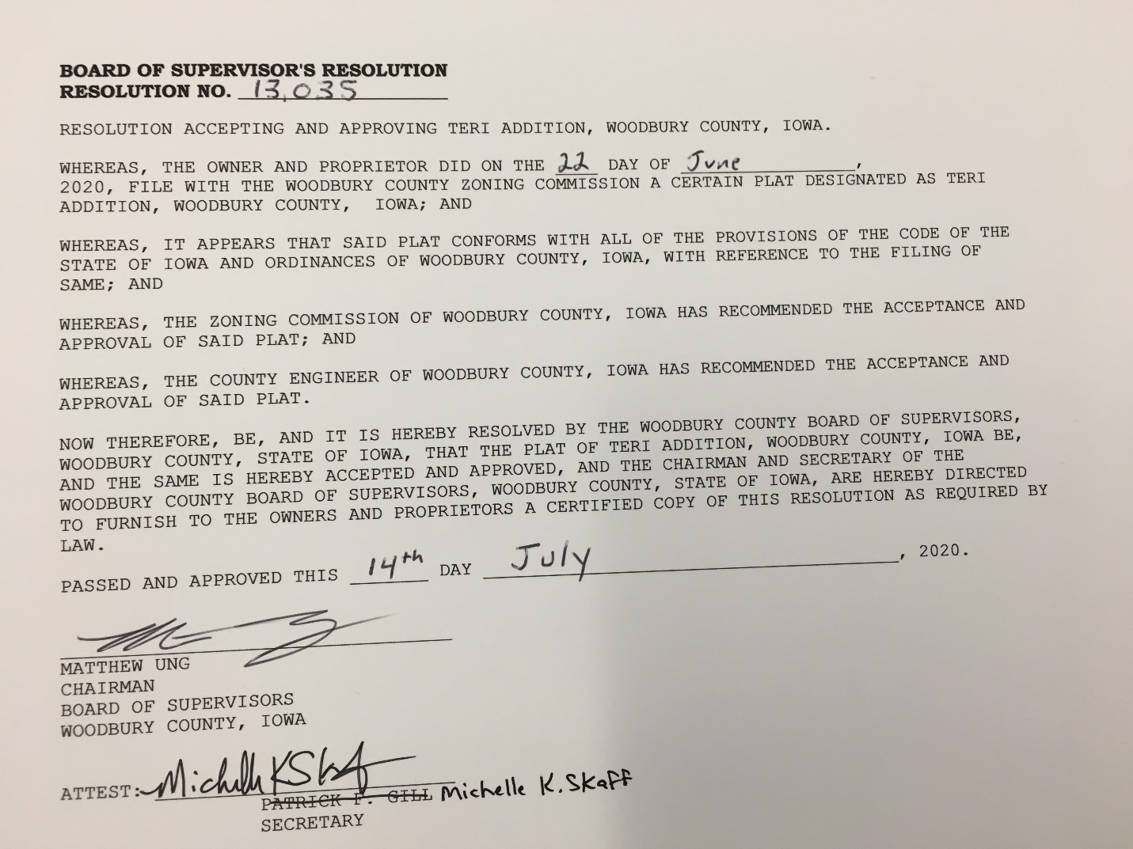

BOARD OF SUPERVISORS' RESOLUTION
RESOLUTION NO. 13,035

RESOLUTION ACCEPTING AND APPROVING TERI ADDITION, WOODBURY COUNTY, IOWA.

WHEREAS, THE OWNERS AND PROPRIETORS DID ON THE 22ND DAY OF JUNE, 2020, FILE WITH THE WOODBURY COUNTY ZONING COMMISSION A CERTAIN PLAT DESIGNATED AS TERI ADDITION, WOODBURY COUNTY, IOWA; AND

WHEREAS, IT APPEARS THAT SAID PLAT CONFORMS WITH ALL OF THE PROVISIONS OF THE CODE OF THE STATE OF IOWA AND ORDINANCES OF WOODBURY COUNTY, IOWA, WITH REFERENCE TO THE FILING OF SAME; AND

WHEREAS, THE ZONING COMMISSION OF WOODBURY COUNTY, IOWA HAS RECOMMENDED THE ACCEPTANCE AND APPROVAL OF SAID PLAT; AND

WHEREAS, THE COUNTY ENGINEER OF WOODBURY COUNTY, IOWA HAS RECOMMENDED THE ACCEPTANCE AND APPROVAL OF SAID PLAT.

NOW THEREFORE, BE, AND IT IS HEREBY RESOLVED BY THE WOODBURY COUNTY BOARD OF SUPERVISORS, WOODBURY COUNTY, STATE OF IOWA, THAT THE PLAT OF CLEMZ ADDITION, WOODBURY COUNTY, IOWA BE, AND THE SAME IS HEREBY ACCEPTED AND APPROVED, AND THE CHAIRMAN AND SECRETARY OF THE WOODBURY COUNTY BOARD OF SUPERVISORS, WOODBURY COUNTY, STATE OF IOWA, ARE HEREBY DIRECTED TO FURNISH TO THE OWNERS AND PROPRIETORS A CERTIFIED COPY OF THIS RESOLUTION AS REQUIRED BY LAW.

PASSED AND APPROVED THIS 14TH DAY JULY, 2020.

__________________________________
MATTHEW UNG
CHAIRMAN
BOARD OF SUPERVISORS
WOODBURY COUNTY, IOWA

ATTEST: __________________________
MICHELLE SKAFF
SECRETARY

